Lab Activity 1: Development Environment Setup (15 Minutes)

Step 1: Create a folder named Day02
Step 2: Open the folder using VS Code.
Step 3: Open Terminal.
Step 4: Verify Node.js installation (Run: node -v)
Step 5: Check npm (Run: npm -v)

Mentor Verification:
[ ] VS Code installed
[ ] Node installed
[ ] Terminal working

---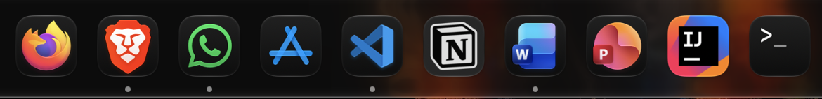
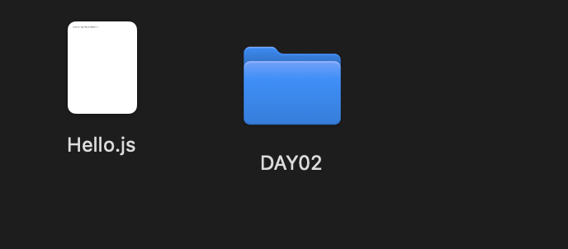
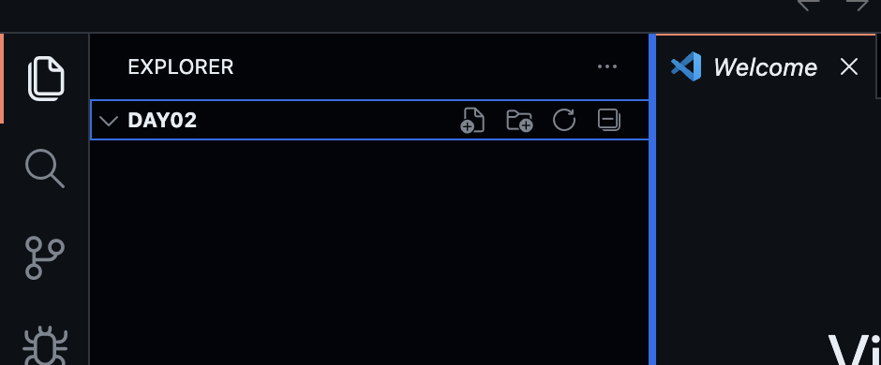
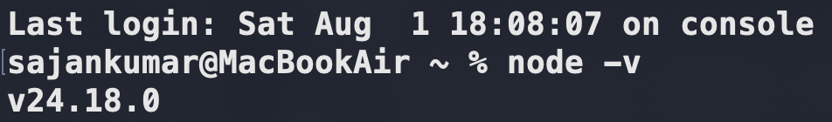
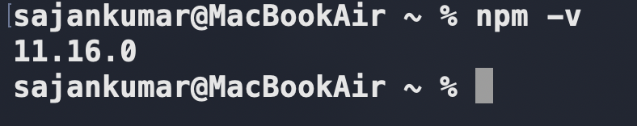

Lab Activity 2: Your First JavaScript File (10 Minutes)
Step 1: Create a file named hello.js
Step 2: Write the following code:
console.log("Hello CodeWeavers!");
Step 3: Save the file.
Step 4: Open the terminal in VS Code and run:
node hello.js
Output:
Hello CodeWeavers!

Reflection
How did the computer display your message?
The Node.js runtime read the hello.js file and executed the console.log() statement. The console.log() function printed the message "Hello CodeWeavers!" on the terminal screen.

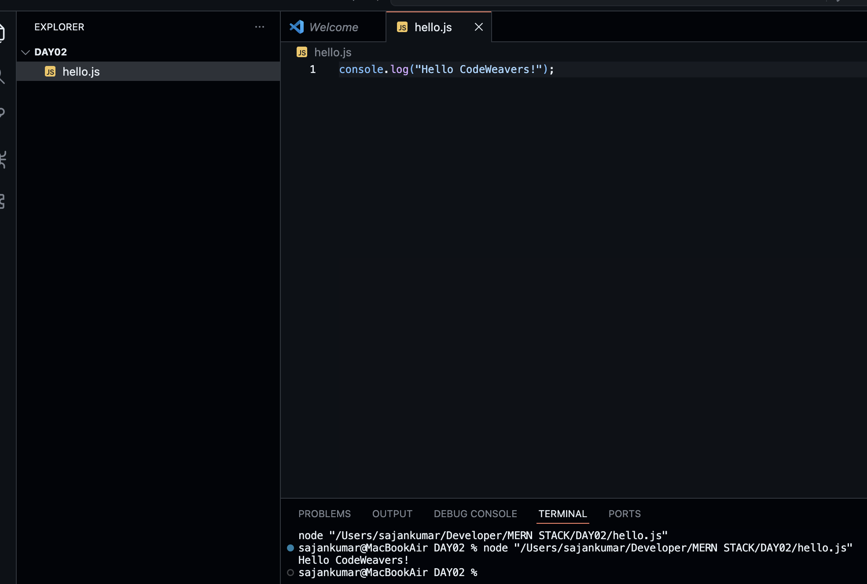

Lab Activity 3: Predict Before You Run (15 Minutes)
Program 1: console.log("Software Engineering");
Prediction: Software Engineering
Actual Output: Software Engineering

Program 2: console.log(100);
Prediction: 100
Actual Output: 100

Program 3: console.log(50 + 25);
Prediction: 75
Actual Output: 75

Program 4: console.log("Age:", 20);
Prediction: Age: 20
Actual Output: Age: 20

Engineering Reflection
Did your prediction match the output? Why?
Yes, my prediction matched the output because console.log() displays the values passed to it. When numbers are added, JavaScript calculates the result first, and when text and numbers are given together, it prints them in the same line.

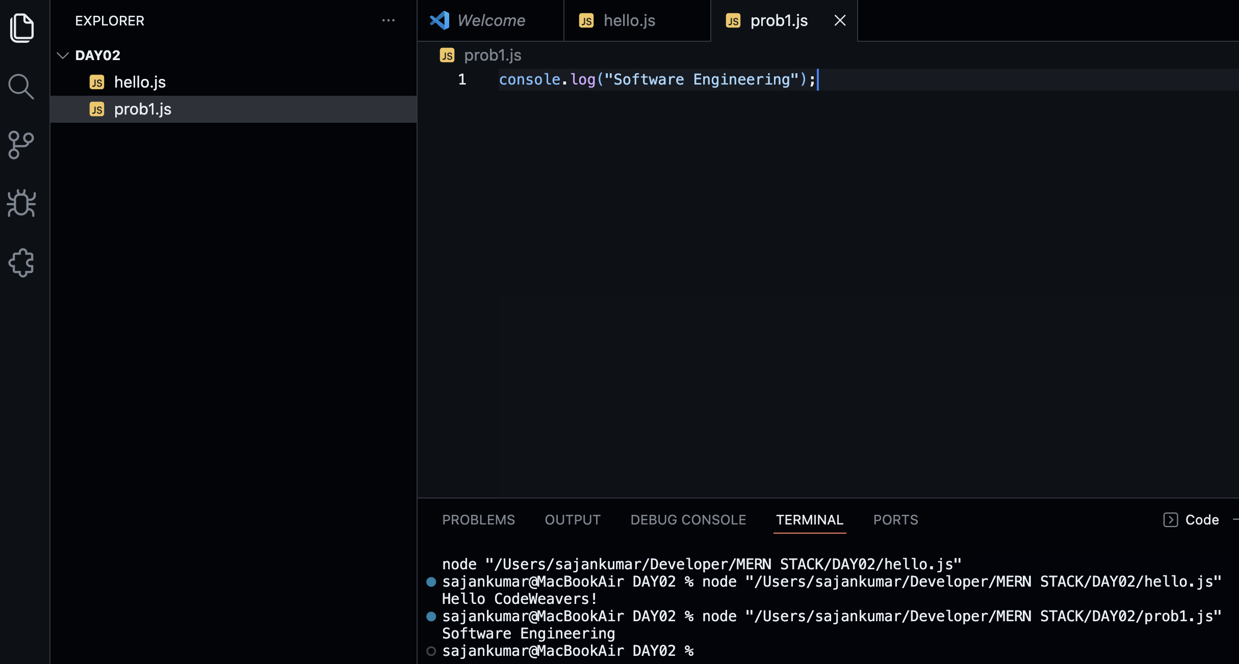

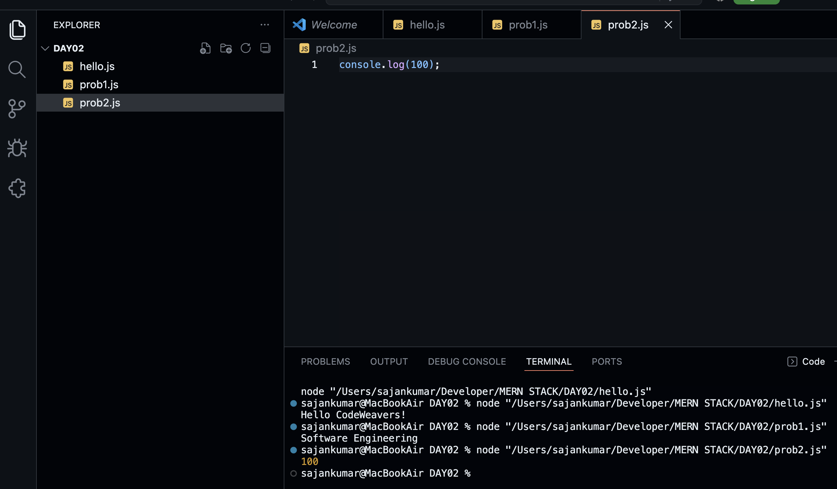
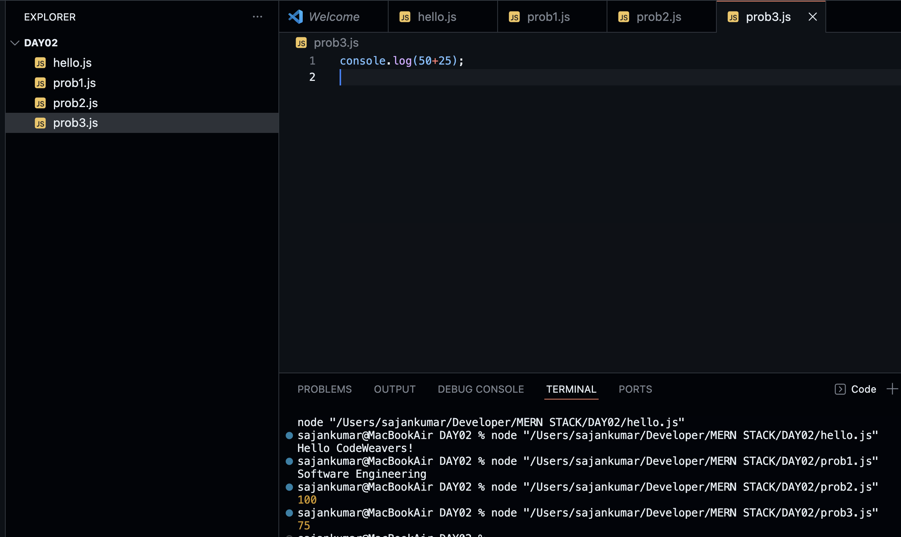
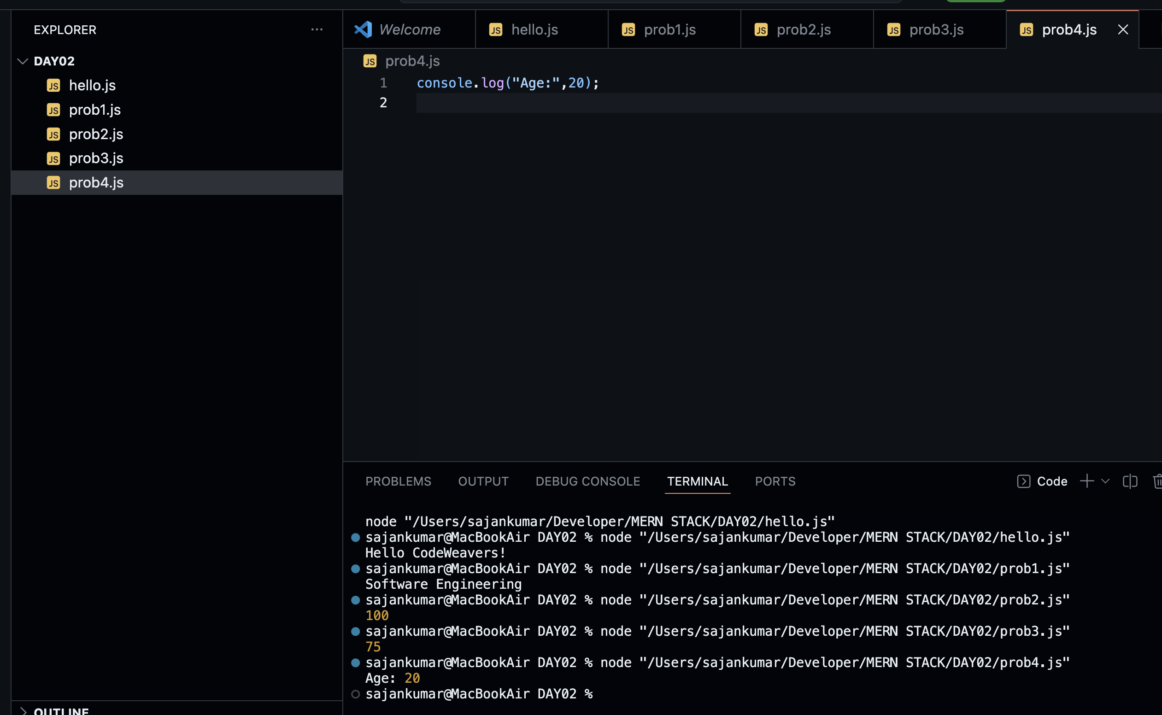

Lab Activity 4: Understanding the Execution Pipeline (10 Minutes)
Correct Flow:
JavaScript Code → Node.js → V8 Engine → CPU → Output

Lab Activity 5: Complete the Concept Map
Human → JavaScript Code → Machine Language → CPU → Output

Lab Activity 6: Real-World Engineering
Chosen Software: WhatsApp
Question | Answer
Programming Language (Guess) | JavaScript
Runtime (Guess) | Node.js
Users | Individuals, students, businesses, families, and organizations
Problem Solved | Instant messaging, voice/video calls, and file sharing over the internet

Lab Activity 7: Explore console.log() (15 Minutes)

Experiment with different inputs.

Program A: console.log("Welcome");
Output: ____________________

Program B: console.log(200);
Output: ____________________

Program C: console.log(15 + 5);
Output: ____________________

Program D: console.log("JavaScript"); console.log("Node.js");
Output: ____________________

Program E: console.log("Code"); console.log(2026); console.log(50 + 50);
Output: ____________________

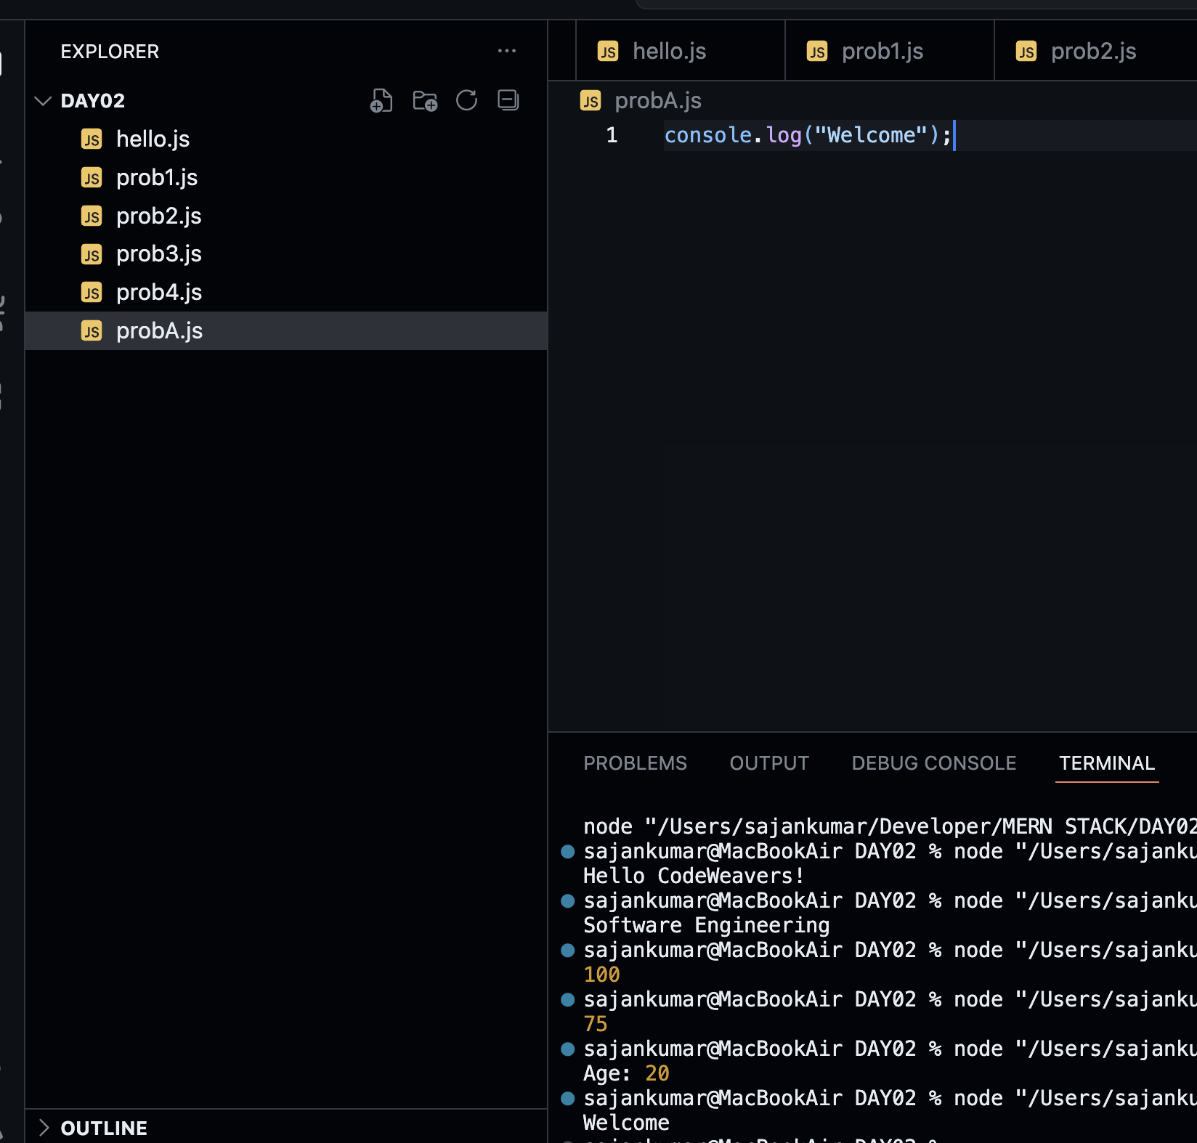
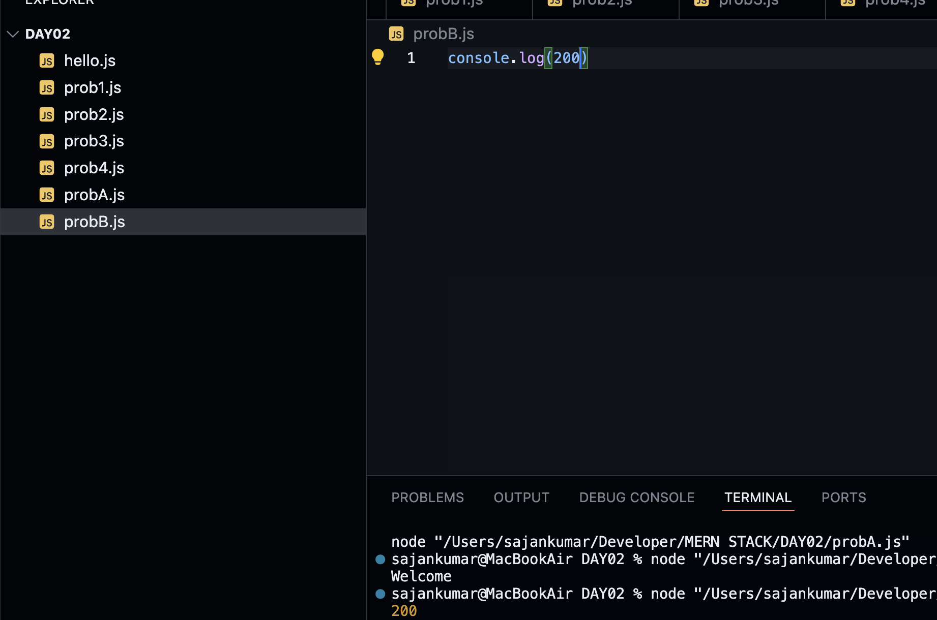
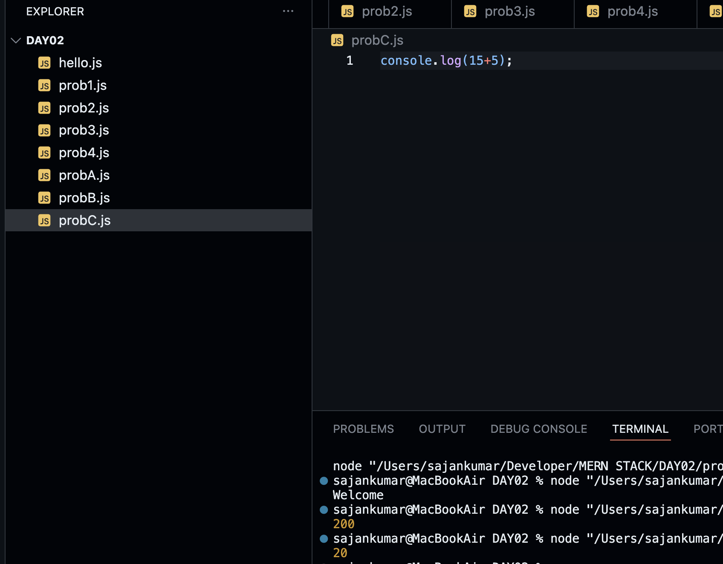
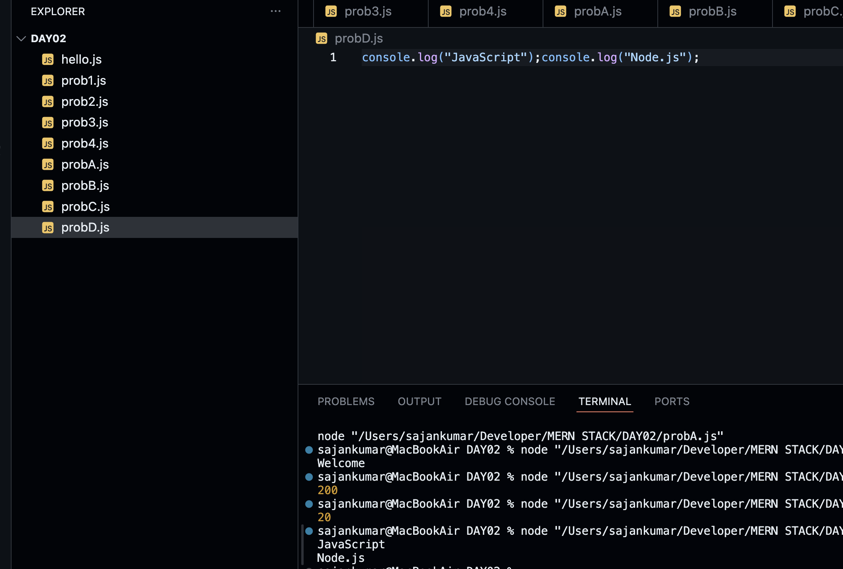
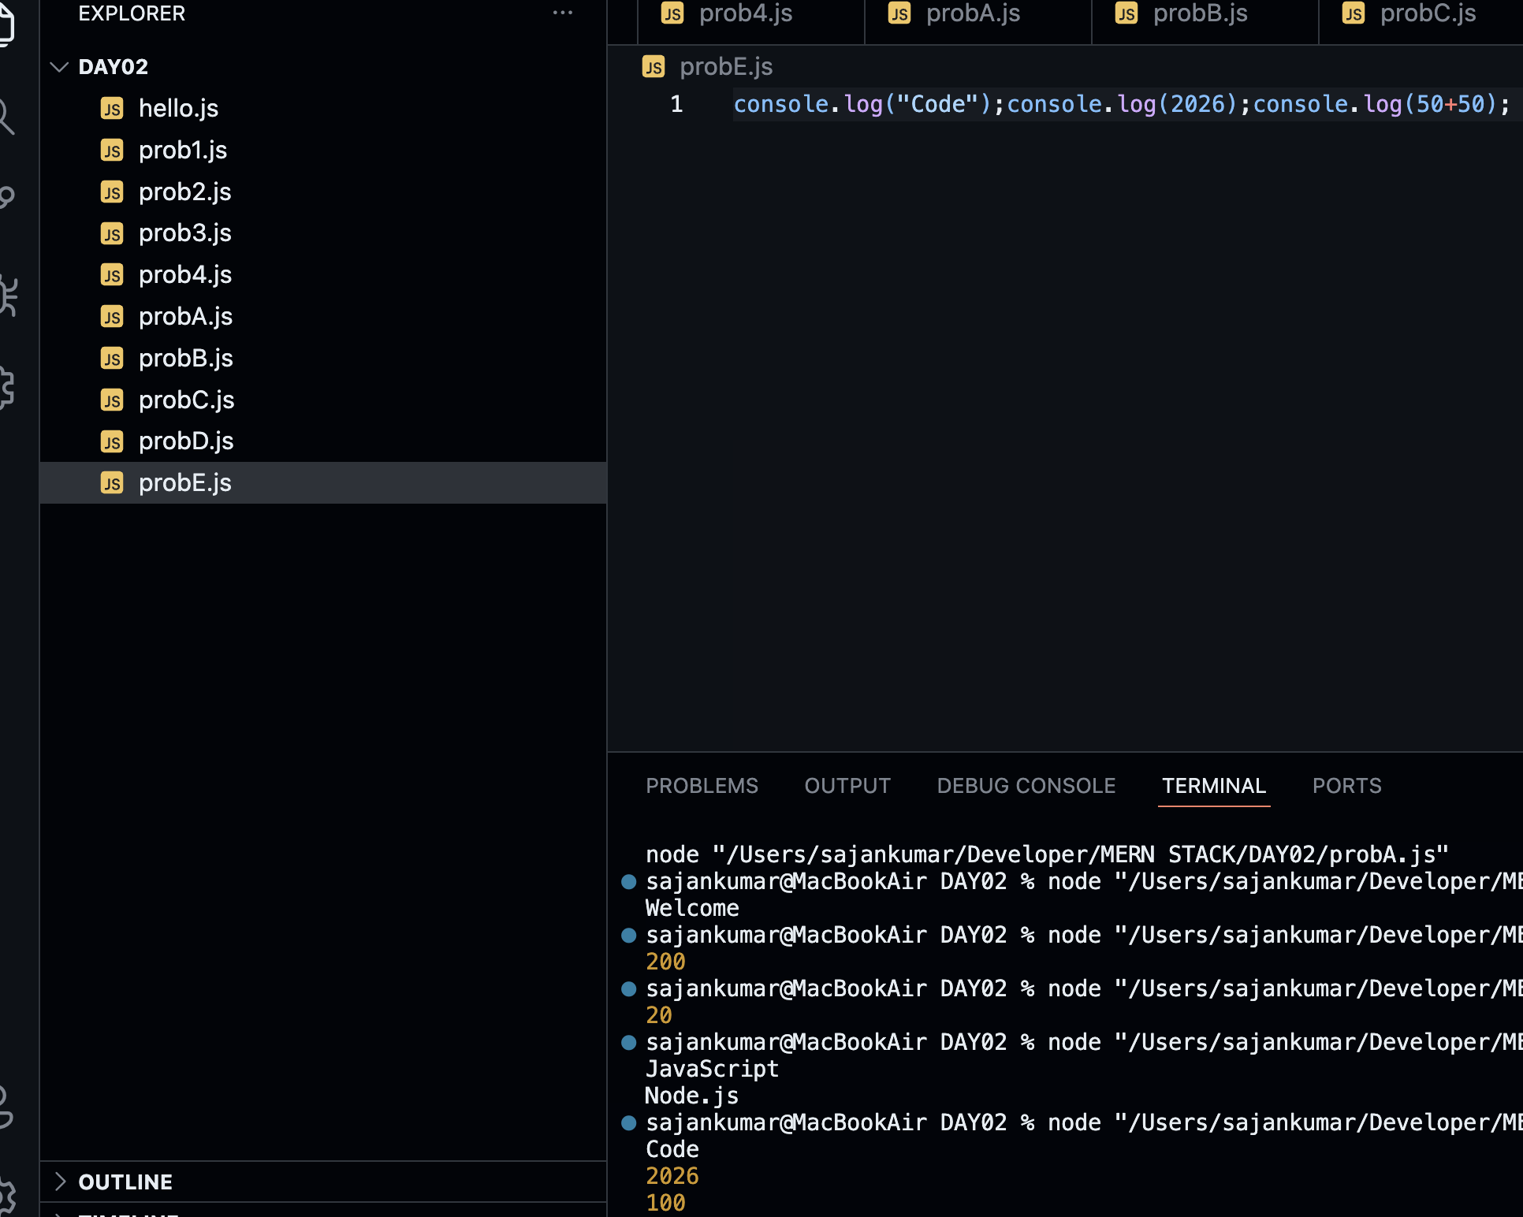
Engineering Challenge

Without copying, create your own file named introduction.js. Print your Name, College, City, Favourite App, Dream Company, and Why you joined CodeWeavers.

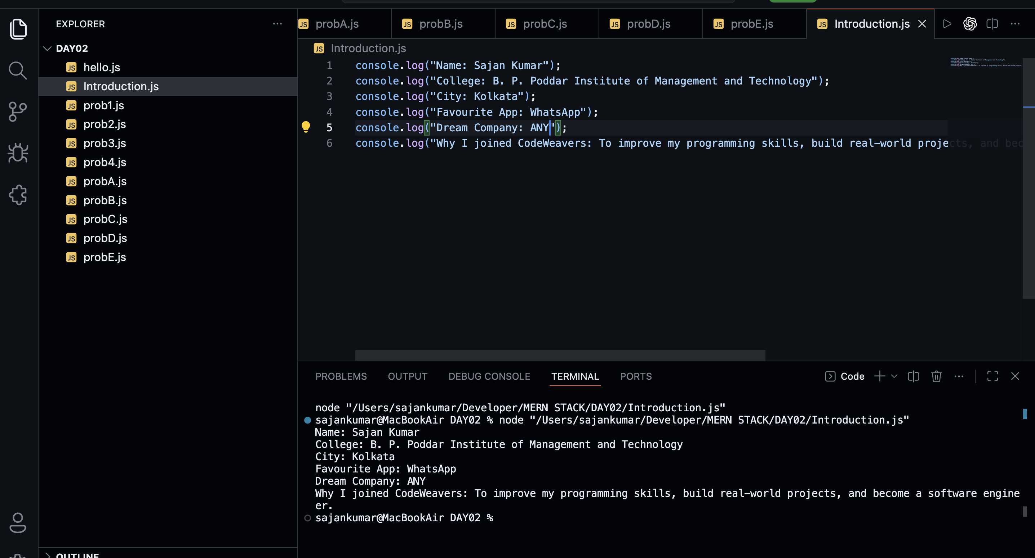
Mini Debugging Challenge

Find the mistake.

Program 1: console.log("Hello)
What is wrong? ___ The closing double quotation mark (") is missing, so the string is not complete._________________________________

Program 2: Console.log("Hello");
What is wrong? ___ Console is incorrect. JavaScript is case-sensitive. It should be console.log() with a lowercase c._________________________________

Program 3: console.log("Welcome") \n console.log("CodeWeavers")
Will it run? Yes / No. Explain: __no \n cannot be written outside a string. It is an escape sequence that only works inside a string, such as:

Program 4: console.log(10+)
What is wrong? __ The expression is incomplete. The + operator is missing a second value (operand).

Engineering Thinking
1. Why can't VS Code execute JavaScript?
VS Code is a code editor. It helps us write and edit code, but it cannot execute JavaScript by itself.

2. Why do we need Node.js?
Node.js provides a JavaScript runtime that executes JavaScript code outside the web browser and displays the output in the terminal.

3. What would happen if computers understood only Binary?
Programming would become very difficult because developers would have to write programs using only 0s and 1s. Programming languages make coding much easier.

4. What is the purpose of programming languages?
Programming languages allow humans to write instructions in a readable form, which are then translated into machine language so computers can execute them.

Team Activity
Discussion: How does this relate to programming?
The activity shows that a computer follows instructions exactly as they are given. If the instructions are clear, correct, and in the proper order, the computer produces the expected result. If the instructions are incomplete or incorrect, the result will also be incorrect. This is exactly how programming works—a programmer writes step-by-step instructions (code), and the computer executes them without making its own decisions.

Bonus
Question: What did you learn from this activity?
Answer:
I learned that computers do not think like humans. They only follow precise instructions. Therefore, writing clear, logical, and complete instructions is essential for creating correct programs.

Bonus Challenge
Technology | Interesting Fact
JavaScript | JavaScript was created by Brendan Eich in 1995, and he developed its first version in just 10 days.
Node.js | Node.js allows JavaScript to run outside the web browser, making it possible to build servers and backend applications.
Google Chrome | Google Chrome uses the V8 JavaScript Engine, which compiles JavaScript into machine code for fast execution.
VS Code | Visual Studio Code is a free, open-source code editor developed by Microsoft and supports many programming languages through extensions.
Home Assignment

Create a project folder named MyFirstProject.
Inside it, create three files: hello.js, about_me.js, dream.js.
Each file should print meaningful information using console.log().
Try changing the messages, numbers, and calculations to observe how the output changes.
